**Omni rover**

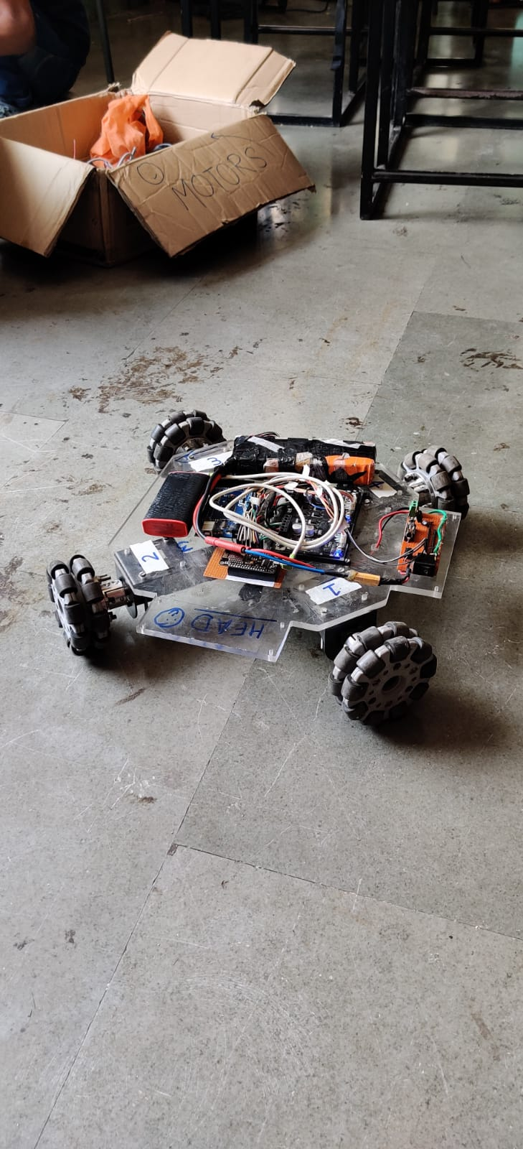

**Team:**

Sumeet sunil Jadhav (Electronics And Coding)

Arya Gaikwad (Coding)

Yash Pame (coding)

**Components:**

Omni wheel

smartelex 15D motor driver

nodeMCU ESP8266

12V ENCODER motor (4)

protection circuit

**Description**

This bot can be controlled over the internet using blynk iot platform by smartphone using blynk app and web dashboard @blynk.cloud , it has Omni directional movement it can make movement irrespective of its position